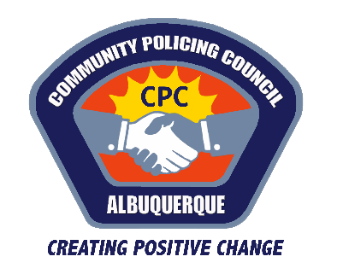
Southwest
Community Policing Council
Zoom Meeting: 6/2/21
Approximately 30 members of the public attended, including APD civilians and councilmembers
CPC members present: Wanda Harrison, Andrea Lester Young, Stephanie Griego, Jonathan Madison, David Reza
- Call to order – 6:00 PM
- Approval of June Agenda - Adopted
- Acceptance of May Minutes - Approved
- Introduction of SW CPC
- Topic: What Happens After Arrest; Adolfo Mendez, Chief of Policy and Planning, 2nd Judicial District Attorney’s Office, Albuquerque, NM.
- The recent history of the 2nd District Attorney’s Office, in Albuquerque.
- Organization of 4,000 outstanding federal felony cases a year
- The Crime Strategy’s Unit
- Repeat Offenders
- Law Enforcement Assisted Diversion
- Escalation of Crime
- Traditional Prosecution Model
- Deterence Theory
- Data Driven Assessment of Risk
- Questions:
- Have defunding initiatives affected prosecution?
- When looking at the number of arrests, are all types of arrests considered illegal?
- Who decides which jurisdictions will prosecute which crimes?

- Mendez Spoke on the Process of Cases Coming to Trial: The composition of crime in Bernalillo County, and utilizing social media to prosecute crime. Also:
- The Alamosa Community Center shooting
- The Andres Loera Homicide
- Actionable Intelligence
- The likelihood of imprisonment by race
- Questions:
- What recommendations for property protection do you have?
- What is the criteria that you use to measure risk?
- Does the DA’s office work with the Albuquerque Violence Intervention Program (VIP)?
- If property crime trends are down, maybe because of Covid-19, and the DA’s office is focusing on violent offenders, will your office be de-emphasizing property crime prosecutions?
- Are other DA’s offices in other cities doing Data Driven Prosecution?
- Do APD morale issues impact the work done by the DA’s office?
- Could you speak about the volunteer opportunities available with the DA’s office?
- Call to Action: Volunteerism with the DA?
- Southwest Area Commander Espinosa Makes Closing Remarks
- Meeting Adjourned – 7:30PM
To watch the Southwest CPC Council June Meeting, please watch below:
Topic: Southwest Community Policing Council
Date: Jun 2, 2021 05:45 PM Mountain Time (US and Canada)
Meeting Recording:
https://cabq.zoom.us/rec/share/WPLcBy40Jn-6nNy7u20kr1me40XZ4Z-R0oEeDNlWEMTrcP1__JyiO91nSagdmzq6.8Nmopms7HDN0pvxp

